

Program Booklet

280.CA/CB – Aircraft Maintenance Technology

TABLE OF CONTENTS

1 INTRODUCTION 1
2 COURSE GRIDS AND DESCRIPTIONS 1
3 EXIT PROFILE 10
4 GOALS AND MINISTERIAL COMPETENCIES OF THE PROGRAM OF STUDY 10
4.1 Goals of the Program-Specific Component 10
4.2 Ministerial Competencies of the Program-Specific Component 11
4.2.1 Common competencies to all students of the program 11
4.3 Goals of the General Education Components 12
5 PROGRAM OF STUDY SPECIFICATIONS 12
6 PROGRAM COMPREHENSIVE ASSESSMENT (PCA) 13
6.1 Course Identification 13
6.2 Achievement Context 13
6.3 Evaluation Plan 15

INTRODUCTION

This Program Booklet consists in a guide for the Aircraft Maintenance Technology (280.CA/CB) program. It contains various information, starting with a brief description of the program: its definition, goals, nature of the program, etc. The goals of the general education components as well as the goals of program-specific components are also described. The course grids offer an overview of the planning of the learning tasks and thoughts to support your academic success.

More precisely, the Program Booklet includes:
- the course grids and course descriptions,
- a presentation of the exit profile,
- the Ministerial competencies and program goals,
- the characteristics of the program of study,
- the details related to the Program Comprehensive Assessment (PCA).

To learn more about student life rules, the conditions to obtain a Diploma of college studies
(DCS), and other essential information related to the success and integration at Cégep Édouard-Montpetit, consult the following:

- The Cegep’s Internet Site (available in French only)
- Le site “ Ma Réussite” à l’ÉNA ( available in French only)
- Mon cheminement au collegial (available in French only)
- Le Parcours d’avenir (available in French only)

COURSE GRIDS AND DESCRIPTIONS

In the following pages, you will find the course grids and descriptions.

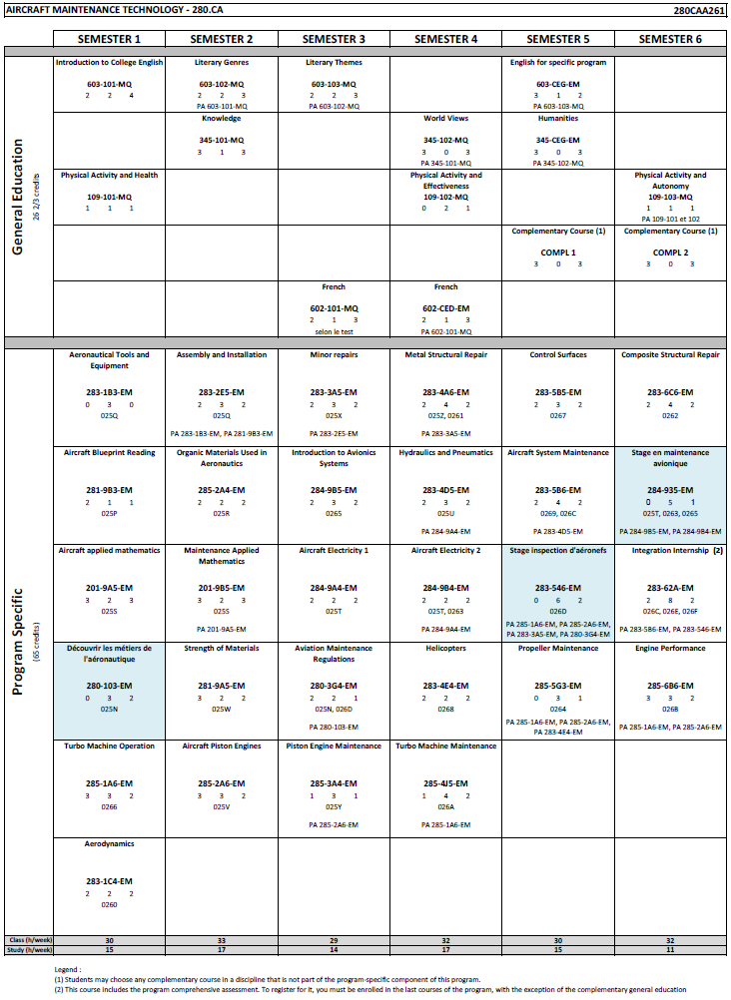
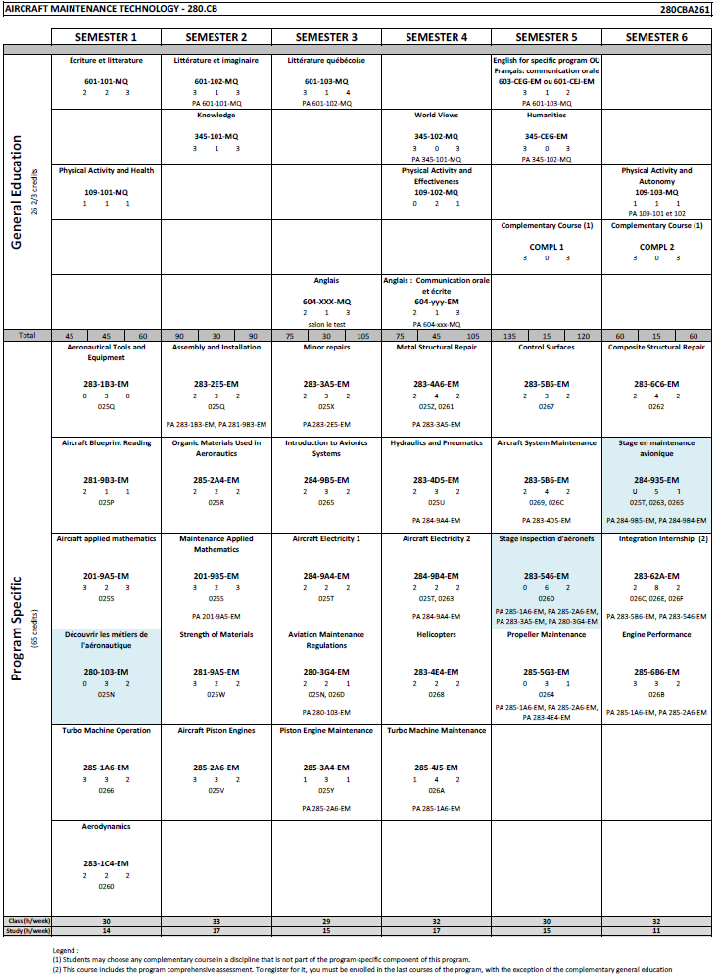

Semester 1
283-1B3-EM Aeronautical Tools and Equipment 0-3-0
This course introduces students to the safe and proper use of tools and equipment commonly used in aircraft maintenance. They will learn to select the appropriate instruments for the tasks at hand, to fabricate simple components, and to apply safety and cleanliness standards in the workshop. The activities, primarily hands-on, take place in a hangar or workshop and aim to develop essential skills for handling aeronautical tools according to industry standards.
280-103-EM Découvrir les métiers de l'aéronautique (course given in French) 0-3-2
Ce cours d’introduction permet à la personne étudiante de découvrir les métiers de l’aéronautique en explorant les fonctions de travail, les milieux professionnels, les exigences réglementaires et les comportements attendus dans le domaine. À travers des activités variées (visites, recherches, simulations, travaux pratiques), elle développera sa compréhension du cadre normatif, de la terminologie spécialisée et des conditions d’exercice propres aux secteurs de la maintenance, de l’avionique et du génie aérospatial. Ce cours constitue une base essentielle pour la poursuite des apprentissages dans les programmes techniques du domaine.
281-9B3-EM Aircraft Blueprint Reading 2-1-1
This course introduces students to the interpretation of plans, technical drawings, and specifications related to aircraft components, assemblies, and systems. They will learn to identify parts, understand standardized symbols, and extract the technical information necessary for maintenance. The activities, combining theory and practice, aim to develop essential skills for reading plans in a work environment in compliance with aeronautical industry standards.
201-9A5-EM Aircraft Applied Mathematics 3-2-3
This course develops the mathematical foundations required for aeronautical applications. Students will learn to model situations, perform algebraic, trigonometric, and vector calculations, solve systems of equations, and interpret technical results. The course combines theory and practice to strengthen skills related to analysis and problem-solving in an aeronautical context.
285-1A6-EM Turbo Machine Operation 3-3-2
This course focuses on the operation and verification of aircraft turbomachinery. Students will learn to identify components, interpret technical documentation, perform functional tests, and analyze results. Activities combine theory and laboratory work to develop essential skills for planning maintenance activities on turbine engines, in accordance with Transport Canada standards.
283-1C4-EM Aerodynamics 2-2-2
This first-semester course deals with the aerodynamic principles applied to aircrafts. Students will learn to establish links between the various aerodynamic principles influencing the behavior of an aircraft and its components (the airframe, flight controls, propeller operation, and structural and surface repairs).
Semester 2
283-2E5-EM Assembly and Installation 2-3-2
PA 283-1B3-EM, PA 281-9B3-EM
This course focuses on the application of techniques for shaping, assembling, and installing aeronautical components according to industry standards. Students will learn to interpret technical drawings, operate specialized tooling, fabricate and install parts, and verify the conformity of their work. The activities, combining theory and practical experience in the laboratory and hangar, aim to develop essential skills for performing work safely and in accordance with aeronautical standards.
201-9B5-EM Maintenance Applied Mathematics 3-2-3
PA 201-9A5-EM
This course introduces differential and integral calculus as applied to aircraft maintenance. Students will learn to model technical phenomena, solve equations, analyze experimental data, and interpret results in real-world contexts. The course combines theory, practice, and numerical tools to develop the essential mathematical skills for technical analysis and decision-making.
285-2A4-EM Organic Materials Used in Aeronautics 2-2-2
This course introduces students to the properties, selection, and use of fuels, lubricants, plastics, and solvents used in aeronautics. Through theoretical and practical activities, they will learn to analyze the characteristics of these materials, perform quality and contamination tests, and apply current safety and environmental standards.
281-9A5-EM Strength of Materials 3-2-2
This course develops the principles of strength of materials as applied to aircraft maintenance. Students will learn to perform calculations of forces, moments, and stresses, conduct mechanical tests, and apply heat and corrosion treatments. The course combines theory and practice to strengthen skills related to the analysis and reliability of aircraft components.
285-2A6-EM Aircraft Piston Engines 3-3-2
This course introduces students to the operation of aircraft piston engines and their related systems. They will learn to identify components, interpret technical documentation, detect malfunctions, and perform functional tests according to industry standards. The activities, combining theory and practical laboratory work, aim to develop essential skills for the verification, analysis, and adjustment of piston engines for safe and compliant maintenance.
Semester 3
285-3A4-EM Piston Engine Maintenance 1-3-1
PA 285-2A6-EM
This course focuses on the maintenance and overhaul of aircraft piston engines. Students will learn to plan and execute engine disassembly, inspection, repair, assembly, and verification tasks in accordance with industry standards. Activities include reviewing technical documentation, practical laboratory work, bench testing, and working on actual engines in an environment that meets Transport Canada requirements.
283-3A5-EM Minor Repairs 2-3-2
PA 283-2E5-EM
This course focuses on techniques for cleaning, inspecting, and repairing minor damage to aircraft structures and components. Students will learn to identify and assess damage, apply corrosion treatment methods, and use technical documentation to perform compliant repairs. Activities, combining theory and practical work in the laboratory and hangar, aim to develop essential skills for preventive and corrective maintenance in accordance with aeronautical industry standards.
284-9A4-EM Aircraft Electricity 1 2-2-2
This course introduces students to the basic principles of electricity and the maintenance of direct- current circuits on aircraft. Through theoretical activities and laboratory work, students learn to measure, verify, and diagnose simple circuits, interpret electrical diagrams, and handle electrical components and systems according to industry standards.
280-3G4-EM Aviation Maintenance Regulations 2-2-1
PA 280-103-EM
This third-semester course is common to both the Aircraft Maintenance Technology and Avionics Technology programs. Students will analyze the responsibilities of a future aircraft maintenance technician (AMT) in order to perform maintenance activities while taking into account Canadian civil aviation regulations and standards, as well as standard practices recognized by the aircraft maintenance community.
284-9B5-EM Introduction to Avionics Systems 2-3-2
This course introduces students to basic avionics systems, including communication, navigation, instrumentation, and display systems. They will learn to analyze the operation of these systems, perform basic technical operations, and analyze their operational status. Activities include theoretical presentations, practical exercises in the hangar and workshop, consultation of bilingual technical documentation, and the use of diagnostic tools. This course develops essential skills for avionics system maintenance, in accordance with industry standards.
Semester 4
283-4A6-EM Metal Structural Repair 2-4-2
PA 283-3A5-EM
This course focuses on the planning, execution, and verification of repairs to aircraft metal structures. Students will learn to analyze damage, use technical documentation, shape and assemble metal components, and apply industry standards to ensure repair compliance. The activities, combining theory and practical laboratory work, are designed to develop essential skills for the safe and rigorous structural maintenance of aircraft.
283-4E4-EM Helicopters 2-2-2
This course introduces students to the aerodynamic principles specific to helicopters and their application in maintenance. They will learn to analyze the forces at play, understand the operation of rotary-wing aircraft components, and perform static and dynamic rotor balancing. The activities, combining theory, simulations, and laboratory practice, aim to develop essential skills for the safe and compliant maintenance of helicopters in accordance with industry standards.
284-9B4-EM Aircraft Electricity 2 2-2-2
PA 284-9A4-EM
This course focuses on the analysis, maintenance, and diagnostics of aircraft electrical power and distribution systems. Students will learn to deepen their understanding of electrical diagrams, perform technical operations on direct-current and alternating-current circuits, and diagnose simple malfunctions. Activities include theoretical presentations, hands-on experiments using training panels, simulators, and aircraft, as well as the use of technical manuals and troubleshooting tools. This course develops essential skills for the maintenance, verification, and performance analysis of electrical systems, in accordance with industry standards.
283-4D5-EM Hydraulics and Pneumatics 2-3-2
PA 284-9A4-EM
This course focuses on the analysis, diagnosis, and maintenance of aircraft hydraulic and pneumatic systems. Students will learn to interpret diagrams, perform functional tests, detect anomalies, and propose troubleshooting solutions. The activities, combining theory and practical laboratory work, aim to develop essential skills for the safe and compliant maintenance of power and control systems in accordance with aeronautical industry standards.
285-4J5-EM Turbo Machine Maintenance 1-4-2
PA 285-1A6-EM
This course focuses on the maintenance and overhaul of aircraft turbine engines. Students will learn to disassemble, inspect, repair, reassemble, and test turbomachinery according to industry standards. Activities take place in the laboratory, hangar, or on a test bench, and include reviewing technical documentation, planning tasks, recording data, and performing compliance analysis. This course develops essential practical skills for the safe and rigorous maintenance of turbine engines.
Semester 5
283-5B5-EM Control Surfaces 2-3-2
This course focuses on the maintenance of aircraft flight control systems and rudders. Students will learn to plan inspections, identify anomalies, perform repairs, and adjust components according to industry standards. Activities, combining theory and practice on models and hangar aircraft, aim to develop essential skills for the safe, rigorous, and compliant maintenance of flight control systems.
283-5B6-EM Aircraft System Maintenance 2-4-2
PA 283-4D5-EM
This course focuses on the maintenance of landing gear and various aircraft systems, such as fuel, oxygen, air conditioning, fire and frost protection systems, among others. Students will learn to analyze the operation of these systems, diagnose anomalies, and perform maintenance interventions according to industry standards. The activities, combining theory and practical laboratory work, aim to develop essential skills for the safe, rigorous, and compliant maintenance of aircraft systems.
283-546-EM Stage inspection d'aéronefs (course given in French) 0-6-2
PA 285-1A6-EM, PA 285-2A6-EM, PA 283-3A5-EM, PA 280-3G4-EM
Ce cours permet aux personnes étudiantes de mettre en pratique les procédures d’inspection d’aéronefs dans un contexte simulé de travail en entreprise. Elles apprendront à planifier et exécuter des inspections sur avions et hélicoptères, à repérer des anomalies, à utiliser la documentation technique et à consigner les résultats selon les normes de l’industrie. Les activités, réparties entre les deux types d’appareils, visent à développer des compétences essentielles à l’évaluation de l’état de navigabilité des aéronefs.
285-5G3-EM Propeller Maintenance 0-3-1
PA 285-1A6-EM, PA 285-2A6-EM, PA 283-4E4-EM
This course focuses on the maintenance of propellers and related systems. Students will learn to identify and understand propeller types and their systems, plan and perform maintenance operations, inspect and repair components, and verify the conformity of installations to industry standards. Activities, conducted entirely in a laboratory or hangar, are designed to develop essential skills for the safe and compliant maintenance of aircraft propellers.
Semester 6
285-6B6-EM Engine Performance 3-3-2
PA 285-1A6-EM, PA 285-2A6-EM
This course focuses on analyzing the performance of aircraft piston and turbine engines using the principles of thermodynamics. Students will learn to plan and conduct tests, interpret the results, and assess performance according to industry standards. The activities, divided between theory and laboratory practice, aim to develop essential skills for the rigorous and safe evaluation of aircraft engine performance.
283-62A-EM Integration Internship 2-8-2
PA 283-5B6-EM, PA 283-546-EM
This course guides students through authentic aircraft and component maintenance tasks in a realistic industrial setting. They will learn to plan interventions based on work orders, execute operations in accordance with civil aviation standards and manufacturer procedures, and meticulously document the work performed. Focused on professional practice, the course fosters autonomy, technical rigor, and the ability to integrate all the essential skills for aircraft and helicopter maintenance.
284-935-EM Stage en maintenance avionique (course given in French) 0-5-1
PA 284-9B5-EM, PA 284-9B4-EM
Ce cours permet aux personnes étudiantes de consolider leurs compétences en maintenance avionique dans un contexte pratique simulant le milieu aéronautique. Elles effectueront des tâches de vérification, de remplacement, de réparation et de remise en service sur des systèmes avioniques et électrique d’aéronefs. Les activités incluent la réalisation d’un harnais électrique, le dépannage de systèmes, l’utilisation de manuels techniques, et la consignation des interventions selon les normes en vigueur. Ce cours développe l’autonomie, la rigueur et la capacité à remettre en service un aéronef, en conformité avec les exigences de l'industrie.
283-6C6-EM Composite Structural Repair 2-4-2
This course allows students to consolidate their avionics maintenance skills in a practical setting that simulates the aeronautical environment. They will perform verification, replacement, repair, and return-to-service tasks on aircraft avionics and electrical systems. Activities include assembling electrical harnesses, troubleshooting systems, using technical manuals, and documenting interventions according to current standards. This course develops autonomy, rigor, and the ability to return an aircraft to service in compliance with industry requirements.

EXIT PROFILE

- Competency 1: To apply principles of the field of aeronautics.
- Competency 2: To maintain aircraft components.
- Competency 3: To maintain aircrafts.

GOALS AND MINISTERIAL COMPETENCIES OF THE PROGRAM OF STUDY

Goals of the Program-Specific Component

The goals of the program-specific component of the Aircraft Maintenance Technology (280.CA/CB) program are based on the general goals of technical training. These goals are:

To help students develop effectiveness in the practice of an occupation, that is:
- to teach students to perform roles, functions, tasks and activities associated with the occupation upon entry into the job market;
- to prepare students to progress satisfactorily on the job (which implies having the necessary technical and technological knowledge and skills in such areas as communication, problem solving, decision making, ethics, health and safety).
To help students integrate into the work force, that is:
- to familiarize students with the job market in general and the context surrounding the occupation they have chosen;
- to familiarize students with their rights and responsibilities as workers.
To foster students’ personal development and acquisition of occupational knowledge, that is:
- to help students develop their autonomy and the desire to learn, and acquire effective work methods;
- to help students understand the principles underlying the techniques and the technology used;
- to help students develop self-expression, creativity, initiative and entrepreneurial spirit;
- to enable students to adopt attitudes essential to their professional success, instill in them a sense of responsibility, and a concern for excellence.
To promote job mobility, that is:
- to help students develop positive attitudes toward change;
- to help students develop the means to manage their careers by familiarizing them with entrepreneurship.

Ministerial Competencies of the Program-Specific Component

Common competencies to all students of the program

Competency Code | Statement of the Competency
025N | To analyze the occupation.
025P | To interpret schematics, drawings, assembly plans and installation plans.
025Q | To apply shaping, assembly and installation techniques.
025R | To use organic and synthetic materials.
025S | To model and interpret mathematical results as they apply to aircraft maintenance.
025T | To maintain direct-current circuits on an aircraft.
025U | To inspect the operation of power and control components of hydraulic and pneumatic systems.
025V | To inspect the operation of aircraft piston engines.
025W | To perform activities related to the resistance of materials used in the aircraft industry.
025X | To clean, inspect and protect aircraft materials.
025Y | To overhaul aircraft piston engines.
025Z | To prepare and assemble sheet metal.
0260 | To apply principles of aerodynamics.
0261 | To maintain the metal structures and structural components of an aircraft.
0262 | To maintain aircraft structures and structural components made of composite materials, wood and fabric.
0263 | To verify simple direct-current circuits on an aircraft.
0264 | To maintain propellers and propeller-related systems.
0265 | To verify communications, navigation and instrumentation systems.
0266 | To verify the operation of aircraft turbine engines.
0267 | To maintain flight controls and flight control surfaces.
0268 | To apply principles of aerodynamics to flight and helicopter maintenance.
0269 | To maintain landing gear.
026A | To overhaul aircraft turbine engines.
026B | To assess the performance of piston and turbine engines.
026C | To maintain aircraft systems.
026D | To inspect airplanes and helicopters.
026E | To maintain airplanes.
026F | To maintain helicopters.

Goals of the General Education Components

General education is an integral part of every program of study and, from a program-based perspective, it is linked to program-specific training by fostering the development of skills necessary for all programs of study. As such, it contributes to the development of the skills that define the exit profile of the graduate of each program of study through the courses of complementary general education and, in particular, the following four disciplines:

- language of instruction and literature,
- humanities,
- second language,
- physical education.

Upon completion of their college studies, thanks to general education courses, students will be able to appreciate literary works, texts and other artistic productions from different periods and schools of thought. Students will have mastered the French language, through which they will have learned to communicate effectively both orally and in writing. They will have learned to analyze philosophical works or texts from different periods and schools of thought. They will be able to demonstrate rational, critical and ethical thinking, as well as master the rules of basic discourse and argumentation. They will have acquired better knowledge of the English language and will have improved both orally and in writing. They will have learned how to develop a healthy and active lifestyle and to recognize the influence of lifestyle on the practice of physical activity and sport. Thanks to the general education courses, students will be able to demonstrate autonomy and creativity in their thinking and actions. They will have developed strategies that promote reflective feedback on their knowledge and actions. Finally, through complementary general education courses, students will have learned to open up to fields of human activity other than their area of specialization.

PROGRAM OF STUDY SPECIFICATIONS

- A unique program in Quebec
- Program duration: 3 years
- Laptop program
- Internships are completed on campus, directly in ÉNA’s facilities
- Program recognized by Transport Canada
- Possibility to obtain credit for knowledge and experience for your Aircraft maintenance engineer (AME) licence from Transport Canada
- Possibility to add prerequisite courses to certain university programs in your school path
- Possibility to participate in a work-study program
- Three (3) program-specific courses given in French

PROGRAM COMPREHENSIVE ASSESSMENT (PCA)

Course Identification

The Program Comprehensive Assessment (PCA) takes place in the capstone course. This course constitutes the culmination of the program of study. The associated ministerial goals define the target to be achieved at its completion and draw on the main learnings developed during the training. This course assesses the students’ achievement of the set of objectives and standards determined for the program.

Capstone course name |  | Integration internship
Capstone course number |  | 283-62A-EM
Capstone course competency codes
026C | To maintain aircraft systems.
026E | To maintain airplanes.
026F | To maintain helicopters.

Achievement Context

The capstone activity will consist of assigned maintenance tasks on components and aircrafts, to be carried out during the last three weeks of the semester, at a rate of eight hours per week. Each task will be authentic and will follow the same three steps.

Designed to simulate a situation in an aeronautical company, students will have to plan a task to accomplish, carry it out in accordance with standards, and then document the maintenance activities that were performed. The activity will be carried out entirely in the workshops of ENA.

For each maintenance task, students must first plan their intervention by gathering relevant information, by verifying the applicability of the documentation and the aircraft configuration, by preparing their work area as well as the necessary tools and equipment. Students must then carry out the task by selecting and using the appropriate tools, performing the necessary tests, and respecting standard practices as well as the manufacturer's procedures. Finally, students must complete the documentation by clearly recording the tasks carried out, the traceability of parts, the tests and their results, as well as any anomalies observed, in accordance with the writing standards and the limits of intervention. Students, equipped with their personal protective equipment (PPE), will arrive at the scheduled time to receive their assigned task. They will then begin their planning by gathering the relevant technical documentation and the necessary tools. Next, students will go to their workstation to perform the task in accordance with the manufacturer's standards or current industry practices, while respecting health and safety rules. Once the intervention is complete, students will carefully record all the steps carried out, based on current standards and references. This process must be rigorously applied to each assigned maintenance task.

Evaluation Plan

Theme: To maintain aircraft systems and components
**Maintenance Definition: Overhaul, repair, required inspection or modification of an aeronautical product, or the removal of a component from or its installation on an aeronautical product (TCCA).

Activity | Based on a work order, plan the work, perform the maintenance task and complete the required documentation.
Competency |  | Steps | Deliverables | Performance Criteria | Weighting
Apply standard practices from the aeronautical field. |  | Step 1: Plan the work to be carried out  - Gather relevant information.  - Ensure the documentation is accurate according to the aircraft.  - Check the current aircraft configuration in relation to the task, as well as the preparation of the work area and the necessary equipment.  - Efficiently organize the tasks to accomplish. | Planning chart for each task | - Accurate identification of:  - standards  - specifications  - occupational health and safety rules  - Accurate interpretation of the scope of their duties within the company  - Accurate description of the type of equipment  - Careful consultation of the relevant technical documentation  - Accurate interpretation of:  - specifications  - standards  - maintenance procedures  - information contained in technical drawings, schematics and diagrams  - Appropriate choice of operations, according to:  - standards and specifications  - objectives and needs  - the characteristics of various aircraft  - Thorough assessment of work priorities, according to:  - the inspections and tasks to be performed  - the severity of defects  - Realistic determination of work steps involved  - Appropriate choice and verification of the availability of the equipment required for the operations  - Appropriate preparation of equipment and work area  - Relevant development of a work plan that considers the current configuration of the aircraft and applicable standards  - Appropriate and relevant choice of information sources necessary for the execution of the upcoming task  - The work plan demonstrates a logical organization of the task to be performed and aims to answer the initial problem | 10%
To maintain aircraft components.  To maintain aircrafts. |  | Step 2: Perform maintenance activities  - Choose the tools and use them appropriately.  - Perform the applicable tests.  - Conform to standard practices.  - Follow the manufacturer's procedures. | Task or set of assigned tasks. | - Proper start-up of aircraft systems  - Appropriate use of maintenance software  - Correct observance of maintenance procedures  - Appropriate choice and observance of a logical problem-solving process  - Observance of standards and specifications  - Appropriate use of specialized equipment and tools  - Correct performance of the maintenance procedures,  - Verification of the quality of the work  - Systematic, meticulous recording of replacements, adjustments and inspection information as the task is being performed | 50%
Apply standard practices from the aeronautical field. |  | Step 3: Complete the required documentation  - Respect the writing standards.  - Record the work done in a concise and relevant manner.  - Record the traceability of parts.  - Record the applicable tests and their results.  - Record any anomalies inherent to the task.  - Respect the limits of intervention. | Job card:  - Attached to each completed task.  - Opened for each anomaly detected during the execution of the task. | - Meticulous recording of the work done.  - Systematic, meticulous recording of technical data. | 30%
Total |  |  |  |  | 90%
Language assessment |  |  |  | Weighting | 10%
Passing grade |  |  |  | Minimum | 60%
At the time of drafting this course framework, the expected deliverables are planned in a controlled environment to ensure adherence to the principles of intellectual integrity. The levels of use of generative artificial intelligence will be specified later, following a thorough analysis of the assessments' capacity to appropriately regulate its use, in accordance with applicable institutional guidelines.

We are referring here to the term " goals " as mentioned in the Cegep’s Institutional Policy on the Evaluation of Student Achievement (IPESA).
We are referring here to the term " goals " as mentioned in the Cegep’s Institutional Policy on the Evaluation of Student Achievement (IPESA).

